Dear Guests!

Thank you for choosing Hungary as your destination. In this document i will provide detailed information on how to get from the Budapest Airport to the Griff hotel (***), and from there to the Kamaraerdei Curling Club.
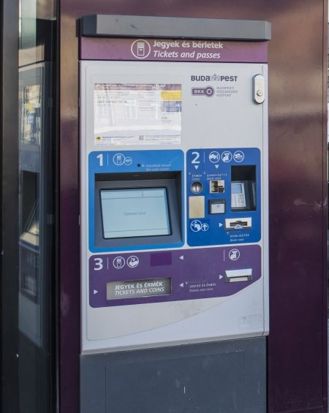
Griff Hotel Budapest (***)
- 1113 Budapest, Bartók Béla út 152
Kamaraerdei Curling Club
- 1112 Budapest, Susulyka u.
From the airport you can also choose the public transportation.
NOTE: Before taking the bus, make sure that you have at least five tickets. You can buy them from the bus driver, or from the nearest BKK ticket vending machine. (----->)

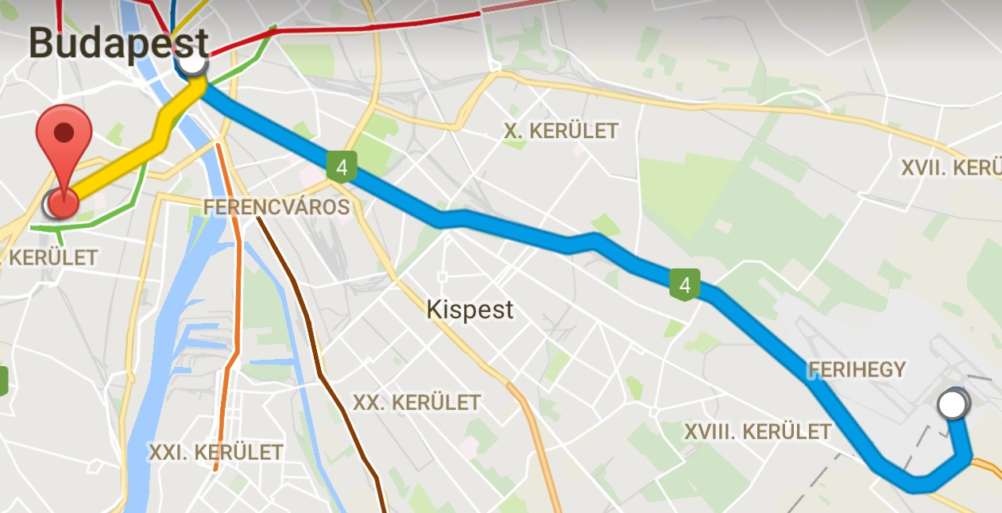
Detailed Public Transportation option to hotel
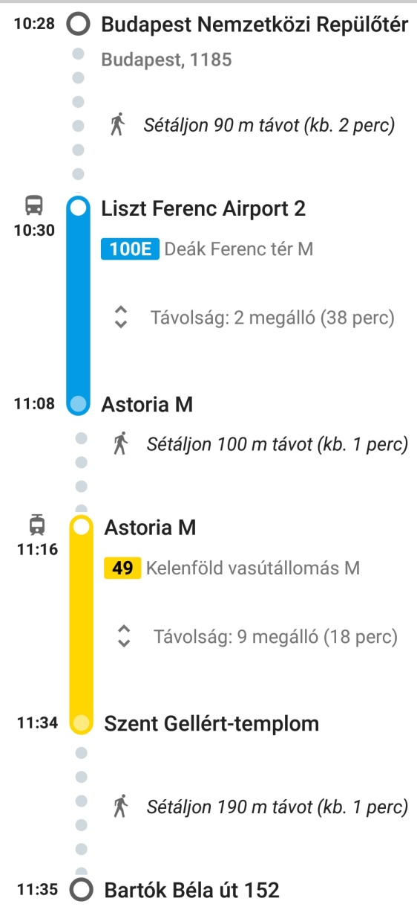
On the map you will see different colored lines and dots.
- The yellow line is the tram
- The blue line is the bus
- The dots are neccerary walking routes
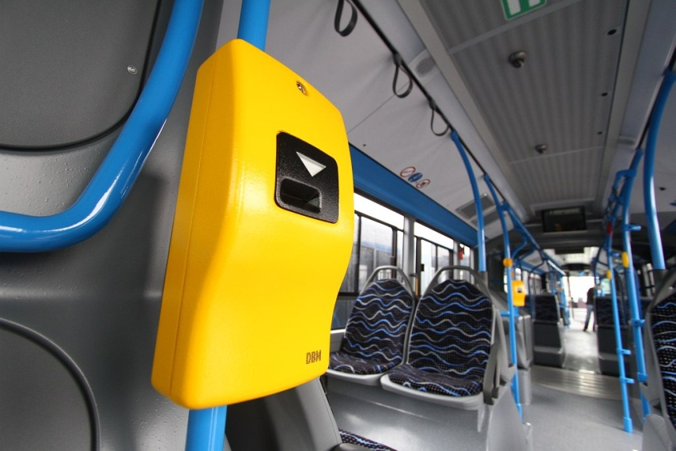
Always use a ticket right after you step on the bus or the tram!

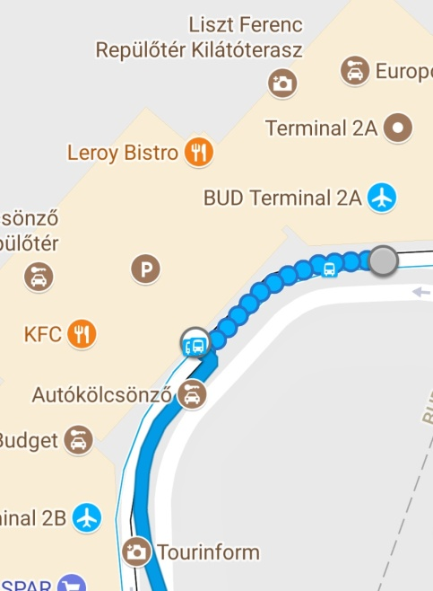

(---) Your first goal will be to find the 100E bus next to the airport (around 90 meters).
Estimated travel time: 38 minutes for 2 stops
Leave the bus at the Astoria bus stop.
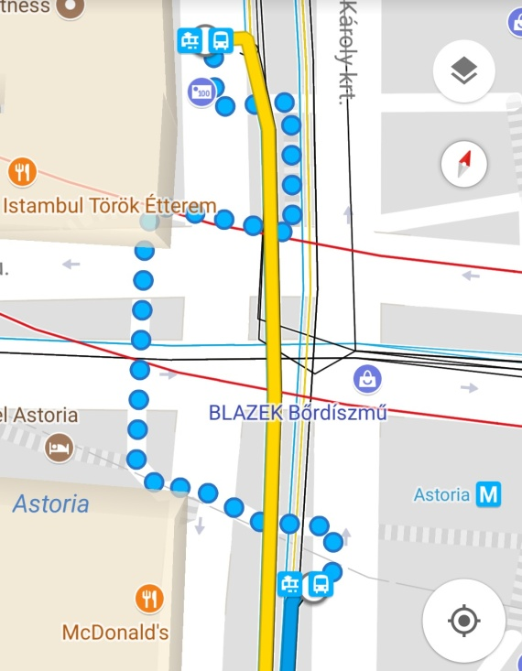
From here you will have to walk approximately 100 meters to the next tram stop. (---)

Take the 49 Tram that goes to Kelenföld Railway station.
Estimated travel time: 18 minutes for 9 stops
Leave the tram at the Szent Gellért Templom tram stop.
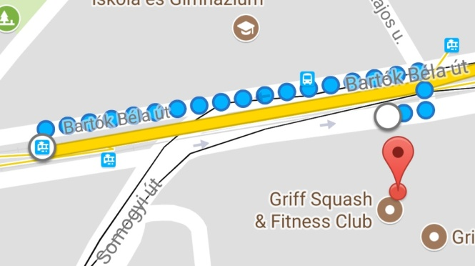
(---)

From here you have to walk 190 meters backwards where the tram came and then turn right. The hotel will be right in front of you.
From the hotel to the curling club
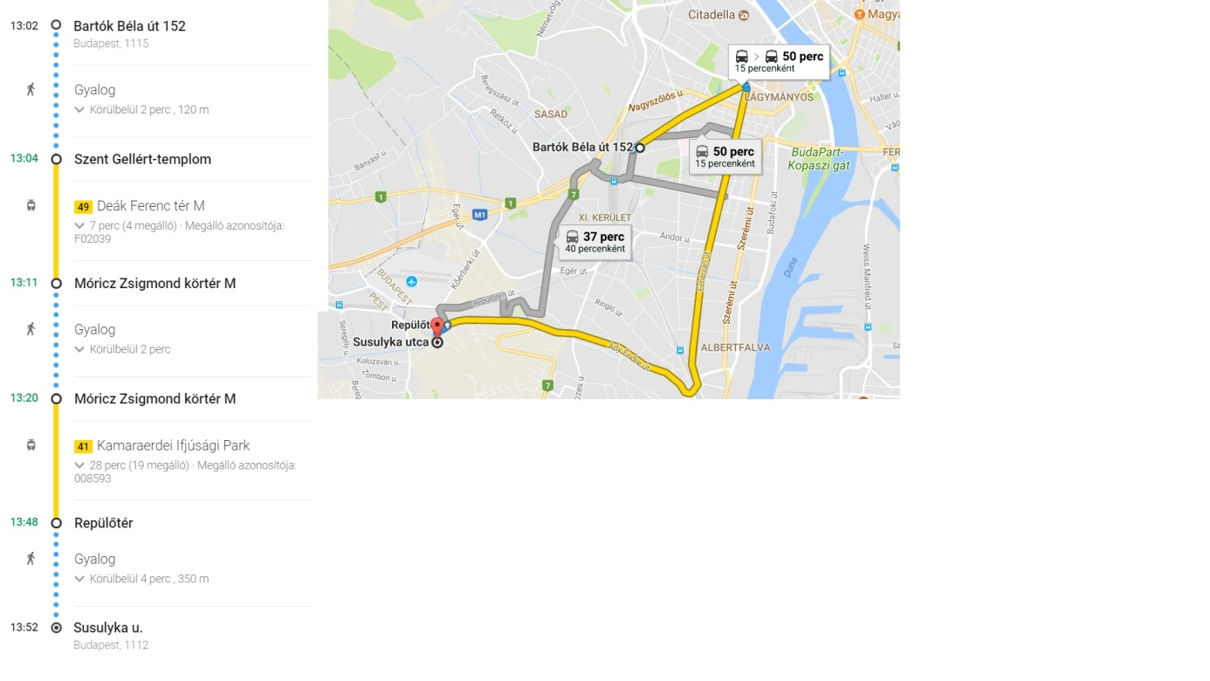
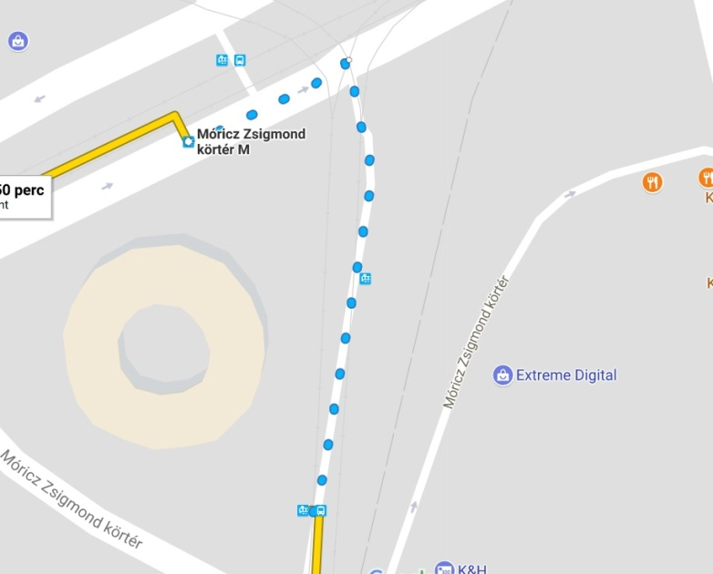
From the hotel go back to the tram stop and take the 49 tram to Deák Ferenc Tér. Get off the Tram at the Móricz Zsigmond Körtér tram stop. Estimated travel time: 7 minutes for 4 stops. From there you have to walk to the 41 tram stop. Take the 41 tram to Kamaraerdei Ifjúsági Park direction.
(---)

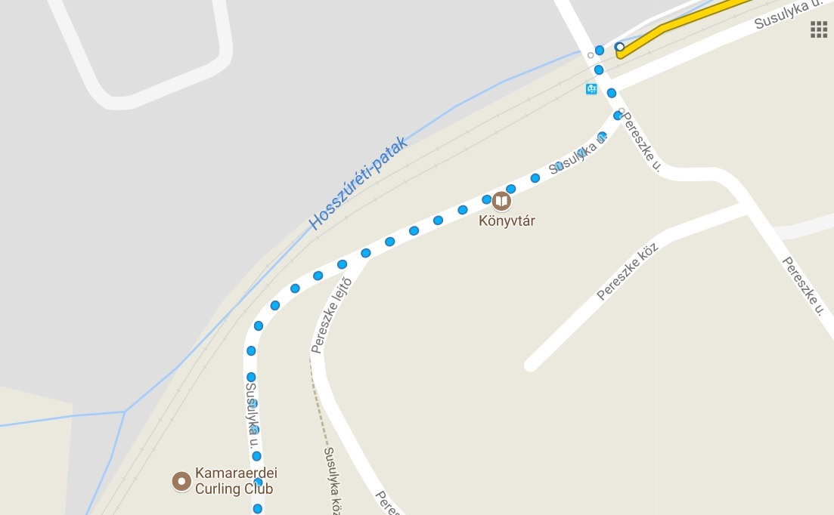
Get off the tram at Repülőtér tram stop. From here you have to walk along Susulyka utca (Susulyka street) until you see the Kamaraerdei Curling Club.

Have a very nice trip and a wonderful stay in hungary!

